GREENHOUSE MONITORING AND CONTROLLING SYSTEM BY USING ANDROID

VANAJA.C,
AP/ECE,
Paavai engineering college,
Namakkal,
vanajachinnappanpec@paavai.edu.in

Kaviyarasu.C,
Student,
Paavai engineering college,
Namakkal,
kavidhanush98@gmail.com
Karthik.R,
Student,
Paavai engineering college,
Namakkal,
ajaykarthik1013@gmail.com,

Sakthivel.A,
Student,
Paavai engineering college,
Namakkal ,
sakthivelanatham44@gmail.com

Abstract— In agricultural country like India, greenhouses form a significant aspect of agricultural and horticulture sectors. In greenhouses, plants are grown-up under auspicious climatic conditions for its production and growth. Thus, monitoring and control of greenhouse environment is essential for production and management of greenhouses. This scheme is designed to monitor and control the covered humidity and weather conditions affecting the plants using embedded system and Android mobile phone. The android phone is linked to a central server which then attaches to microcontroller and humidity sensor through serial communication. Thus, the sensor archives and manages the required weather conditions proved to be appropriate for plant growth. In this scheme, we use GSM module to attach microcontroller &mobile phone. We use five categories of sensors to monitor the growth of the plants. The sensors are temperature, moisture, LDR, humidity, pH sensor. The sensor outputs are record & manage the require weather condition deliver to be suitable for plant growth.

Keywords—Sensor, embedded system, android mobile phone, GSM, microcontroller

Introduction
There is continuous growth in demand for food production technology. India is a country where the economy is dependent on agricultural yield. Agricultural means can satisfy the food production claim. But due to isotropic climatic situations, lack of water pool, agricultural yield does not meet the difficulties.
A greenhouse is a structure in which plants are grown for marketable or research purposes. These structures range in size from slight sheds to very huge buildings, with different types of layer materials, such as a glass or plastic ridge and commonly glass or plastic walls; it heats up because received visible solar radiation (for which the glass is translucent) from the sun is immersed by plants, soil, and other things inside the structure. Air warmed by the heat from hot interior surfaces is engaged in the building by the ridge and wall. In addition, the warmed structures and plants inside the greenhouse re-radiate some of their thermal energy in the infrared spectrum, to which glass is partially dense, so some of this energy is also surrounded inside the greenhouse. However, this later process is a minor player linked with the former (convective) process. Thus, the primary heating mechanism of a greenhouse is convection. Ventilation is one of the most significant components in a effective greenhouse. If there is no appropriate ventilation, greenhouses and their plants can become prone to problems. The main resolutions of ventilation are to control the temperature to the optimal level, and to ensure undertaking of air and thus prevent build-up of plant pathogens (such as Botrytis cinereous) that prefer still air conditions. Ventilation also confirms a supply of fresh air for photosynthesis and plant respiration, and may enable significant pollinators to access the greenhouse crop. Ventilation can be achieved through use of apertures - often controlled mechanically - and recirculation fans.

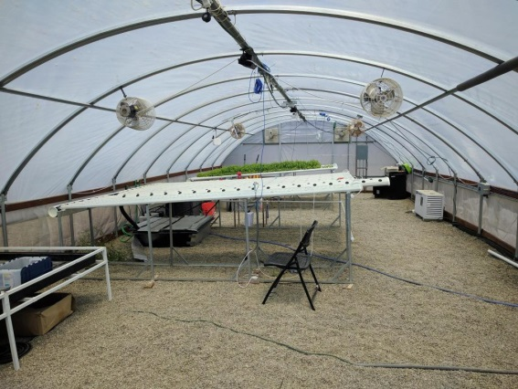

Figure: Greenhouse Monitoring and Control System

Embedded greenhouse monitoring and control is planned to deliver a highly detailed micro-climate data for plants within a greenhouse environment with an advanced method of increasing temperate crops in a tropical environment by means of microclimatic conditions. The greenhouse was furnished with conservative wired sensors that provide interpretations of the air temperature, light intensity and nutrient solution temperature in the mixing tank. The sharpness and absorption of the nutrient solution were manually measured, and adjusted accordingly, and high resolution data, composed with the deployment of a network of wireless sensors to deliver sufficient data to progress a model for the growth of these crops under aeroponic conditions.

GREENHOUSE EFFECT IN GLOBAL WARMING AND INTERNET OF THINGS
The greenhouse effect is the method thanks to which Earth has a higher temperature than it would have without it. The gases that release heat also known as greenhouse gases fascinate the energy released out by the Earth and reproduce a part of it back to Earth. Of all the energy that the Earth obtains from the Sun, a part of it around 26% is replicated to space by the atmosphere and clouds. Some part of it is fascinated by the atmosphere, around 19%.
The rest successes the ground and heats the surface of the Earth. This fascinated energy is radiated out of the earth in the form of Infrared Waves. These IR waves deep the atmosphere above the Earth. The atmosphere again releases this energy it established from the Earth both upwards and downwards. The energy referred downwards consequences in a higher equilibrium temperature that if greenhouse gases were inattentive. This greenhouse effect is important to supporting life on Earth.
The greenhouse gases accountable for the greenhouse effect are:
- Water vapour
- Carbon Dioxide
- Methane
- Ozone
The unnecessary burning of fossil fuels such as petrol, coal etc. has occasioned in a growth in the number of greenhouse gases in the atmosphere resulting in a phenomenon known as Global Warming. This is a growth in the ambient temperature of Earth which will negatively affect life on Earth.

Global warming
Global Warming refers to the growing temperature of the Earth’s climate scheme and its related properties. Technical evidence has convincingly proven that the Earth’s temperature is in fact growing and has increased by 0.85ºC. This has an impact consumes affected different regions differently. The properties include rising sea levels, disappearing glaciers, loss of sea ice in the extremes, warming global temperatures, changing rainfall, extension of deserts etc.
This raises substantial threats for humans such as food security from reducing crop yields, submergence of a low-lying area due to the growing sea. To prevent permanent damage to the delicate ecosystems on Earth, scientists have decided that the global warming should be limited to a maximum of 2.0ºC relative to pre-industrial levels. Greenhouse effect plays an important role in the rising temperature. And hence to confine global warming we need to bound the greenhouse effect and the gaseous productions that cause the greenhouse effect.
Fourteen of the fifteen years in the 21st century have been the newest years on record with endless incidences of extreme weather, cyclones, droughts, floods etc. All these procedures are some way or the extra have a suggestion with the greenhouse effect and global warming.

Internet of Things
IoT (Internet of Things) is a progressive automation and analytics system which adventures networking, sensing, big data, and artificial intelligence knowledge to deliver complete schemes for a invention or service. These systems allow superior transparency, control, and performance when useful to any industry or system.
IoT systems have claims across productions through their unique flexibility and capability to be appropriate in any environment. They improve data collection, automation, operations, and much more through smart devices and powerful qualifying technology.
The Internet of Things (IoT) is the network of strategies such as vehicles, home-based appliance, electronics, software, actuators, and connectivity which permits these things to connect, interact and exchange data.
The Internet of Things includes spreading Internet connectivity network outside the average devices, such as desktops, laptops, smart phones and tablets, to any variety of conventionally dumb or non-internet-enabled physical devices and ordinary objects. Embedded with technology, these devices can attach and interact over the Internet, and they can be remotely monitored and controlled.
The applications of IoT in ecological monitoring are wide-ranging environmental protection, extreme weather monitoring, water safety, threatened species protection, commercial farming, and more. In these applications, sensors detect and quantity every type of environmental change.

SYSTEM DESIGN AND WORKING
In this system user connects with the centralized unit using SMS. This unit connects with the system through SMS which will established by the GSM with the help of SIM card. The GSM send its data to ARM 7 which is also continuously accepts the data from sensors. After this data is presented on the LCD. After getting the activation command from the subscriber first it checks all the conditioned gives detailed comment to the user. In this system, we are controlling the four main parameters of greenhouse like humidity, temperature, light intensity, soil moisture. And we have used diverse sensors for sensing these different parameters. Also, some determined threshold values are set for all these parameters by the user per the need of climatic conditions required in greenhouse. The paper purposes GSM/Bluetooth created remote controlled embedded system for green house. System gives the information about the situations of parameter like variations in the temperature, water controlled in soil, light intensity and humidity in the atmosphere and set the greenhouse time depending on the temperature humidity light intensity and soil moisture reading from sensors and type of crop.

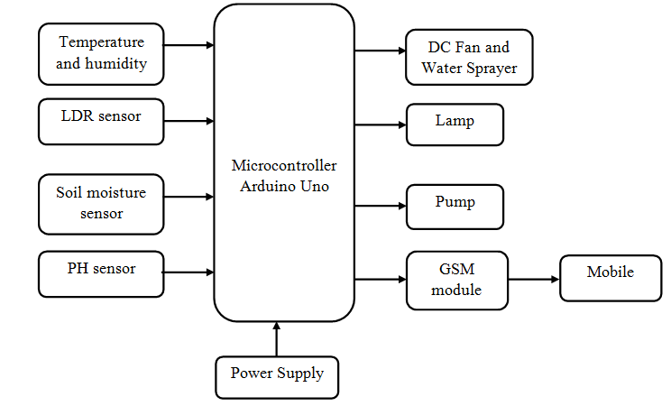

Figure: Implementation of Android based Greenhouse Maintenance and Controlled System

To control these limitations of greenhouse different relays are used. Relay is an electrical switch that open and closed under the control of alternative electrical circuit. Relay can control output circuit of higher influence than input circuit.

HARDWARE DESCRIPTIONS
The word ‘sensor’ is resultant from the word meaning ‘to perceive’ and ‘transducer’ means ‘to lead across’. A dictionary definition of ‘sensor’ is a device that senses a change in a physical incentive and turns it into a signal which can be measured or recorded. This project we are using four types of sensor.
- Temperature and humidity sensor
- LDR sensor
- Soil moisture sensor
- pH sensor

Temperature and Humidity Sensor
DHT11 Temperature & Humidity Sensor structures a temperature & humidity sensor.

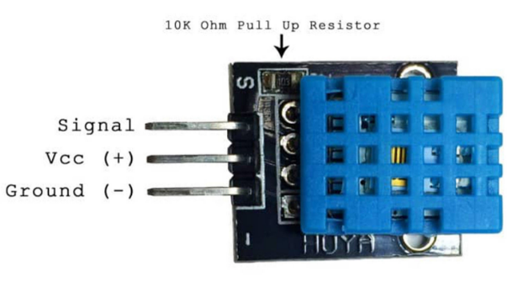

Figure: DHT11 –Temperature and Humidity sensor
Complex with a adjusted digital signal output. By using the limited digital-signal-acquisition technique and temperature & humidity sensing skill, it ensures high reliability and outstanding long-term stability. This sensor includes a resistive-type humidity quantity component and an NTC temperature quantity component, and attaches to a high performance 8-bit microcontroller, offering exceptional quality, fast response, anti-interference ability and cost-effectiveness.
Each DHT11 element is severely calibrated in the laboratory that is enormously accurate on humidity adjustment. The adjustment coefficients are stored as computer operator in the OTP memory, which are used by the device’s internal signal sensing process. The single-wire serial boundary makes system integration quick and easy. Its small size, low power consumption and up-to-20-meter signal communication making it the best choice for various requests, including those most challenging ones. The constituent is 4-pin single row pin package. It is suitable to connect and special packages can be provided per users’ request.

LDR Sensor
Photo resistors, also identified as light dependent resistors (LDR), are light sensitive devices most often used to specify the presence or absence of light, or to measure the light intensity. In the dark, their resistance is very high, occasionally active towards 1MΩ, but when the LDR sensor is uncovered to light, the struggle drops intensely, even depressed to a few ohms, reliant on the light intensity. LDRs have a sensitivity that fluctuates with the wavelength of the light functional and are nonlinear devices.

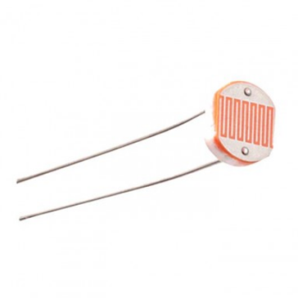
Figure: LDR Sensor

Soil Moisture Sensor
Soil moisture sensors is the quantity of volumetric water that satisfied in the soil. Since the shortest gravimetric quantity of free soil moisture needs removing, drying, and weighting of a sample, soil moisture sensors quantity the volumetric water satisfied indirectly by means of some other property of the soil, such as electrical resistance, dielectric constant, or interaction with neutrons, as a proxy for the moisture content.
The relation between the measured property and soil moisture must be adjusted and may vary dependent on ecological factors such as soil type, temperature, or electric conductivity. Reflected microwave radiation is exaggerated by the soil moisture sensor and is mostly used for remote sensing in hydrology and cultivation. Portable enquiry instruments can be used by farmers or gardeners.
Soil moisture sensors naturally refer to sensors that estimate volumetric water content. Alternative class of sensors measure alternative property of moisture in soils called water potential; these sensors are typically referred to as soil water potential sensors and include tensiometers and gypsum blocks.

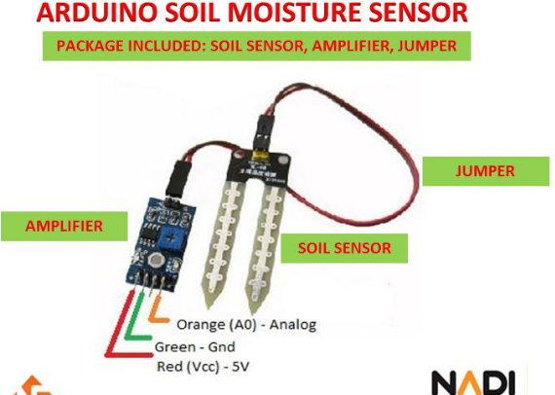
Figure: Soil Moisture Sensor
Measuring soil moisture sensor is most important for agricultural applications to help farmers achieve their irrigation systems more professionally. Knowing the exact soil moisture environments on their fields, not only are farmers able to commonly use less water to produce a crop, they are similarly able to rise yields and the quality of the crop by better-quality management of soil moisture during critical plant growth stages.

pH sensor
A pH meter is a technical instrument that actions the hydrogen-ion movement in water-based resolutions, representing its acidity or alkalinity articulated as pH. The pH meter actions the modification in electrical potential between a pH electrode and a position electrode, and so the pH meter is occasionally referred to as a “Potentiometric pH meter”. The modification in electrical potential narrates to acidity or pH of the solution. The pH meter is used in many applications fluctuating from laboratory research to quality control.
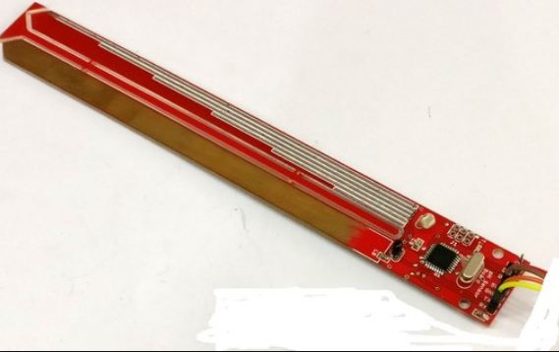
Figure: pH Sensor

GSM Module
GSM or Global System for Mobile Communication is a Wireless Communication standard for mobile telephone systems. It was established by the European Telecommunications Standards Institute (ETSI) as a additional to the 1st Generation Analog Cellular Network. Hence, GSM is frequently called as the 2nd Generation Digital Cellular Network or basically 2G. A GSM/GPRS Module is an IC or chip that attaches to the GSM Network by means of a SIM (Subscriber Identity Module) and Radio Waves. The common radio occurrences in which a typical GSM Module activates are 850MHz, 900MHz, 1800MHz and 1900MHz.Since it is not imaginable to interface a GSM/GPRS Module directly to an exterior device like a microcontroller, we need a arrangement like shown in the following image.

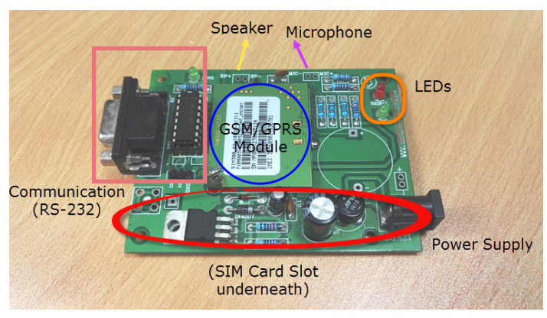
Figure: GSM Module
It consists of the GSM/GPRS Module, slot for inserting a SIM Card, RS-232 Interface for connecting with computer or a microcontroller, signal status LED, power supply and a provision for connecting microphone and speaker. Each GSM/GPRS Module is unique and it can be differentiated by its IMEI Number. IMEI or International Mobile Equipment Identity Number is a 15 – digit unique number associated with mobile phone, satellite phones and other GSM Network devices.
The processor or controller, to which the GSM/GPRS Module is connected to, is responsible for sending the AT Commands to the module. In response, the GSM Module performs command specific tasks like answering a phone call, send an SMS Message, etc.

Arduino UNO
Arduino is an open-source platform cast-off for construction electronics projects. Arduino consists of mutually a physical programmable circuit boarding (often discussed to as a microcontroller) and a part of software, or IDE (Integrated Development Environment) that scores on your computer, used to write and upload computer encryption to the physical board.
The Arduino platform has become relatively popular with people just preliminary out with electronics, and for good reason. Unlike most previous programmable circuit boards, the Arduino does not need a discrete piece of hardware (called a programmer) to load new code onto the sheet – you can basically use a USB cable. Additionally, the Arduino IDE uses a shortened version of C++, making it easier to acquire to program. Finally, Arduino delivers a standard form issue that breaks out the purposes of the micro-controller into a further accessible package.

RESULT AND DISCUSSION

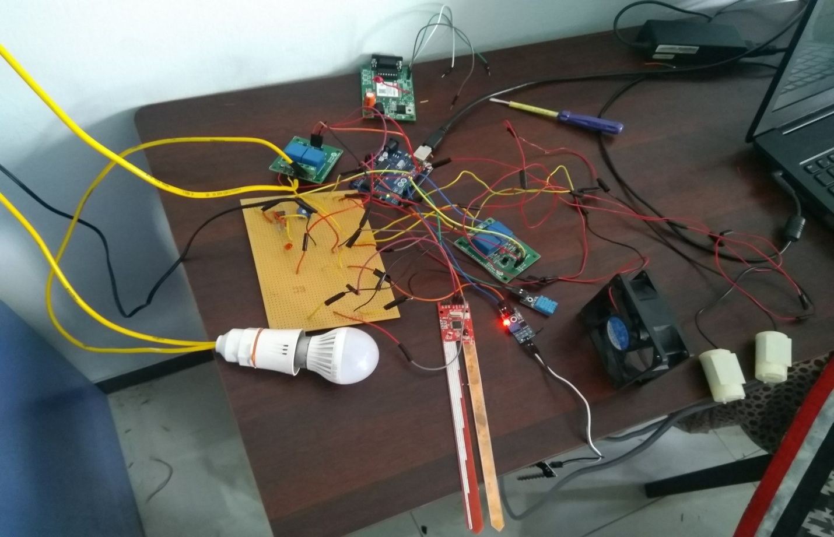

Figure: Hardware Implementation of Greenhouse Monitoring and Controlling System by using android

In Soil moisture sensor, the output voltage is 0, and then the condition of the soil is strong-minded as dry condition. When the voltage is in between 1.9-3.5V, then the condition is said to ideal. When the voltage is greater than 3.5 v, then it is said to be humidity. In Temperature sensor, the output voltage 0.25, then is in initial phase. If the output voltage is 0.26, then is in 1°C. If the output voltage is 0.31, then is in 9°C. In Light dependent resistor, the output voltage is 2.0 v, then it is said to day time. If the output voltage is 4.3 v, then it is said to be night time so that a LED sparks. In pH sensor, the pH value would be indicated as acid, base or neutral.

CONCLUSION

In this project, we are developing an automated system based on Android application for the maintaining and controlling of greenhouse. The system is combination of both android and embedded system. Thus, we get the experience of studying embedded devices and communication protocol. The project shows how technology can reduce human efforts. Thus, this project is a good learning experience. In future, apart from Android phones, the system can be connected to other communication devices like modems or satellite terminal for enabling remote data collection. The system performance can be further expanded by increasing operating speed, memory capacity and instruction cycle period of microcontroller. Also, we can use Wi-Fi, so that the system can be directly connected to the internet. Moreover, Time bound administration of crop yielding materials like fertilizers, pesticides and insecticides can be introduced. To operate multiple greenhouses concurrently, a multi-controller system can be developed.

References
- Ai, Q., Chen, C., “A Smart greenhouse android app”, IEEE Conference Publications. Page(s): 5584 -5587, 2011.

- Akshay C., Nitin Karnwal , Abhfeeth K. A., Rohan Khandelwal., “Wireless Sensing and control for precision Greenhouse Management”, IEEE Paper,2012, Page(s): 52-56.

- J. Breckling, Ed., The Analysis of Directional Time Series: Applications to Wind Speed and Direction, ser. Lecture Notes in Statistics. Berlin, Germany: Springer, 1989, vol. 61.

- Muhammad All Mazidi, The 8051 Microcontroller & Embedded Systems.

- M. Wegmuller, J. P. von der Weid, P. Oberson, and N. Gisin, “High resolution fiber distributed measurements with coherent OFDR,” in Proc. ECOC‟00, 2000, paper 11.3.4, p. 109.

- R. E. Sorace, V. S. Reinhardt, and S. A. Vaughn, “High-speed digital-to-RF converter,” U.S. Patent 5 668 842, Sept. 16, 1997.

- S. M. Metev and V. P. Veiko, Laser Assisted Microtechnology, 2nd ed., R. M. Osgood, Jr., Ed. Berlin, Germany: Springer-Verlag, 1998.

- SumitKumar,MohitKumar, AswinKumar, Praneet Garg, “Monitor and control of Greenhouse Environment ‟The Project GreenBee”, Bharat Institute of Technology , Meerut.

- S.Thenmozhi1,M.M.Dhivya,R.Sudharsan,K.Nirmalakumari “Greenhouse Management Using Embedded System and Zigbee Technology“, International Journal of Advanced Research in Electrical, Electronics and Instrumentation Engineering Vol. 3, Issue 2, February 2014.

